- Apply a custom color theme to a Power BI report that matches the branding of your favorite IPL team, including logo placement and color palette.
ANSWERS:
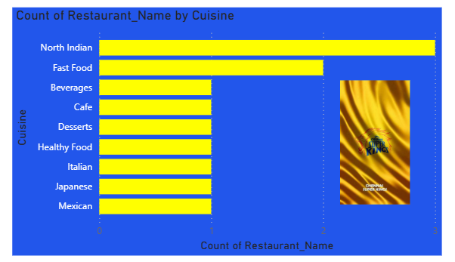

- Design a Flipkart-style sales dashboard in Power BI using gridlines for alignment, and arrange visuals (bar chart, pie chart, KPI card) to create a clean, balanced layout.
ANSWERS:
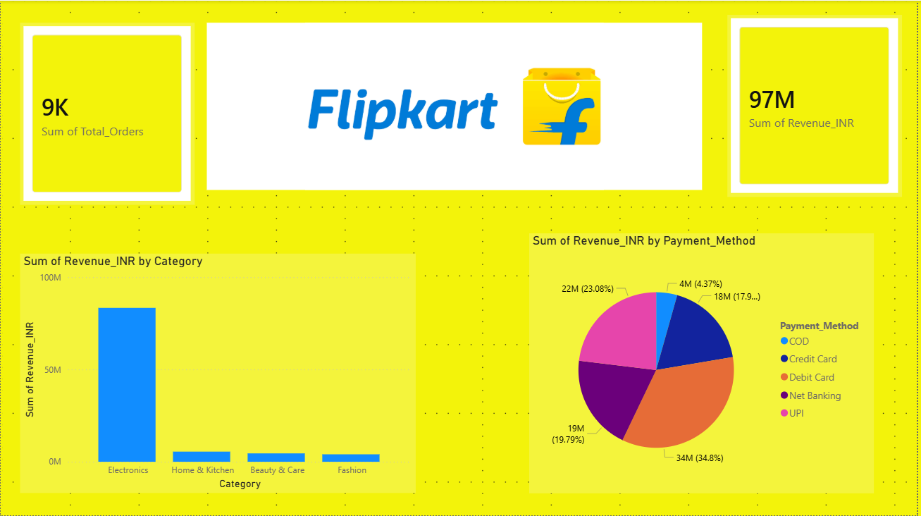

- Set up Row Level Security (RLS) in a Power BI report so that only sales data for a specific city (e.g., Ahmedabad) is visible to users from that city.
Hint: Use the 'Manage Roles' feature to define your rule and test it using 'View as Role'.
ANSWERS:
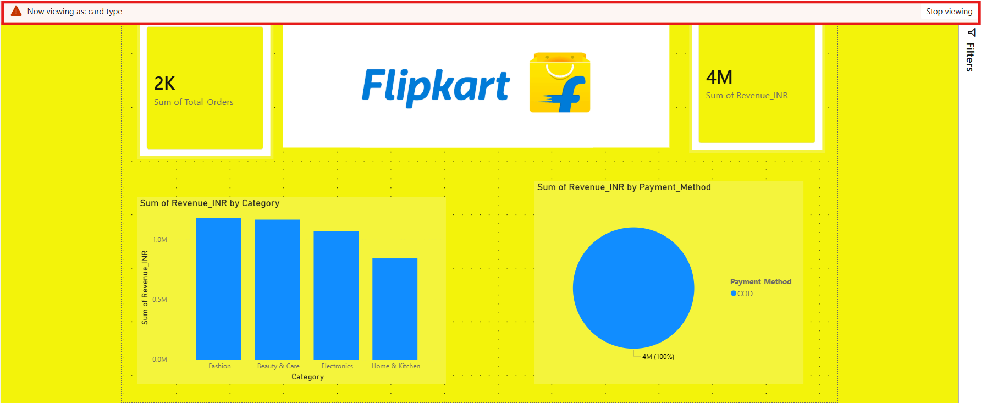

- Publish your customized Power BI report to the Power BI Service and share it with a classmate using their email address.

Constraint: Ensure the report is accessible and viewable by the recipient.
ANSWERS:
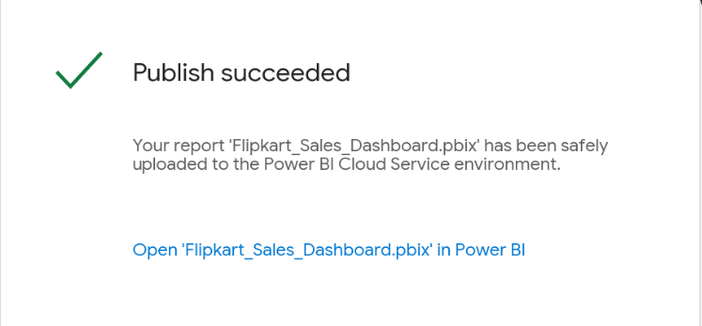

- Align all visuals in your Power BI report using the alignment tools so that the dashboard looks professional and organized, similar to the clean layouts found in apps like Zomato or Spotify.
ANSWERS:
